PolyFiveCorp Project Report

# Cover page

**PolyFiveCorp**

**PolyFiveCorp Project Report**

**IS1201**

**Mr Mar Kheng Kok**

**Muhammad Khairyl (Leader)**

**Ng Qing Hui**

**Nicholas Chua**

**Timothy Yeo**

**Tinesh Kumar**

# COntent page

**Introduction**

Page 3

**Project Proposal**

Page 4 - 14

**Project Plan and Design**

Page 15 - 24

**Program Design**

Page 25

**Problems Encountered**

Page 26

**Future Enhancements**

Page 27

**Conclusion**

Page 28

**Appendixes**

Page 29

# introduction

Our system is an Event Management Application which provides a more easy usage or planning for event organizers such as the admin, event mangers, finance and ticketing. Organizers with different roles have different level of accessibility. It also provides services for the public and for registered members for booking of tickets. Members however have more privileges such as priority in ticket booking, discounts and notifications of upcoming events. This application attracts mainly tourist and locals who are into events.

# project proposal

## Introduction

Our system is an Event Management Application which provides a more easy usage or planning for event organizers such as the admin, event mangers, finance and ticketing. Organizers with different roles have different level of accessibility. It also provides services for the public and for registered members for booking of tickets. Members however have more privileges such as priority in ticket booking, discounts and notifications of upcoming events. This application attracts mainly tourist and locals who are into events.

Features

* Booking of Tickets
* Calendar
* Event Details
* Change of Language

## Functional Specification

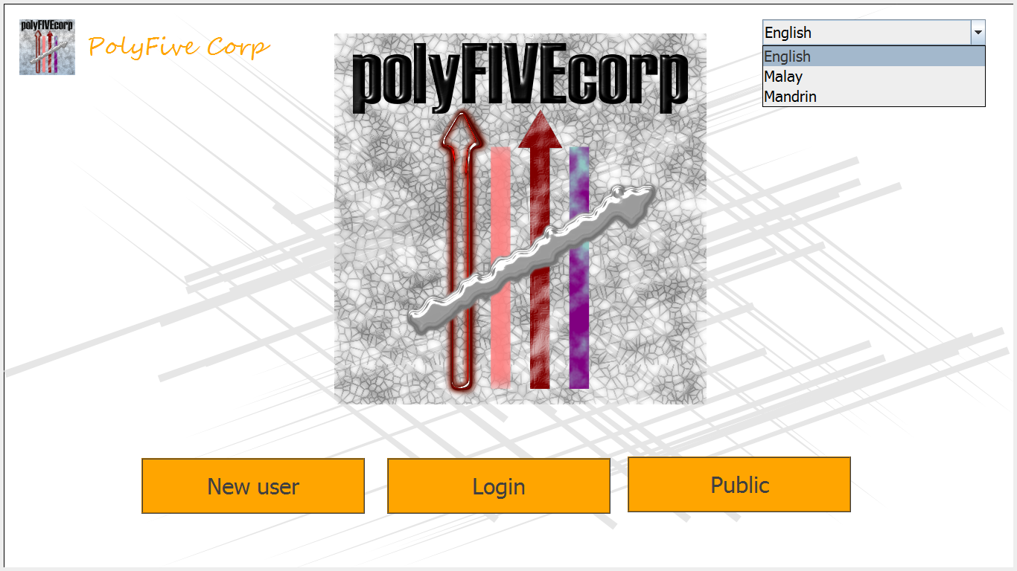

Home Screen- This is the home screen which what the users will see. There will be three tabs at the bottom where users will select what they want to login as. They also have the option two select between three languages which are English, Malay and Mandarin.

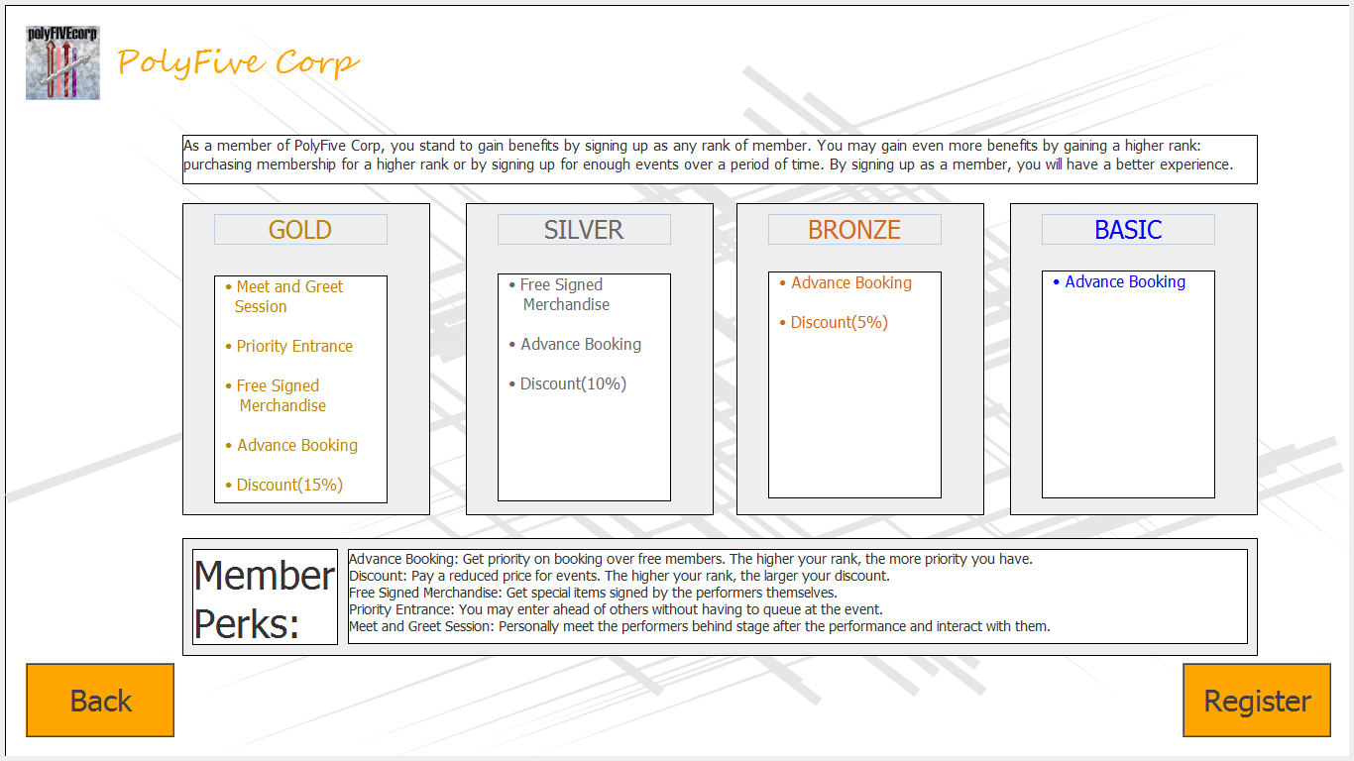

Membership Benefits Information Screen: In this Screen, new users which will be able to gain information on the benefits of the different membership benefits we have to offer. So, after deciding what type of membership they will like to apply for, they will proceed on to the register screen.

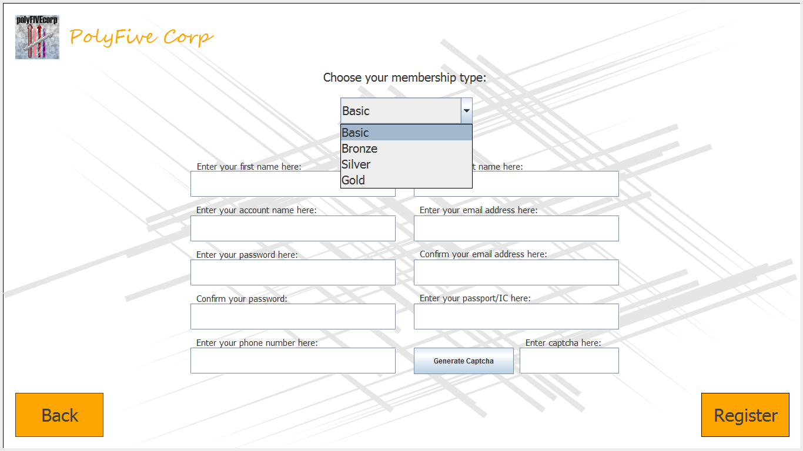

Registeration Screen- Users are able to choose their membership type namely Basic, Bronze, Silver and Gold. They will have to key in the neccessary information required to register. They are also required to enter a captcha to ensure it is a human-being entering all this information.

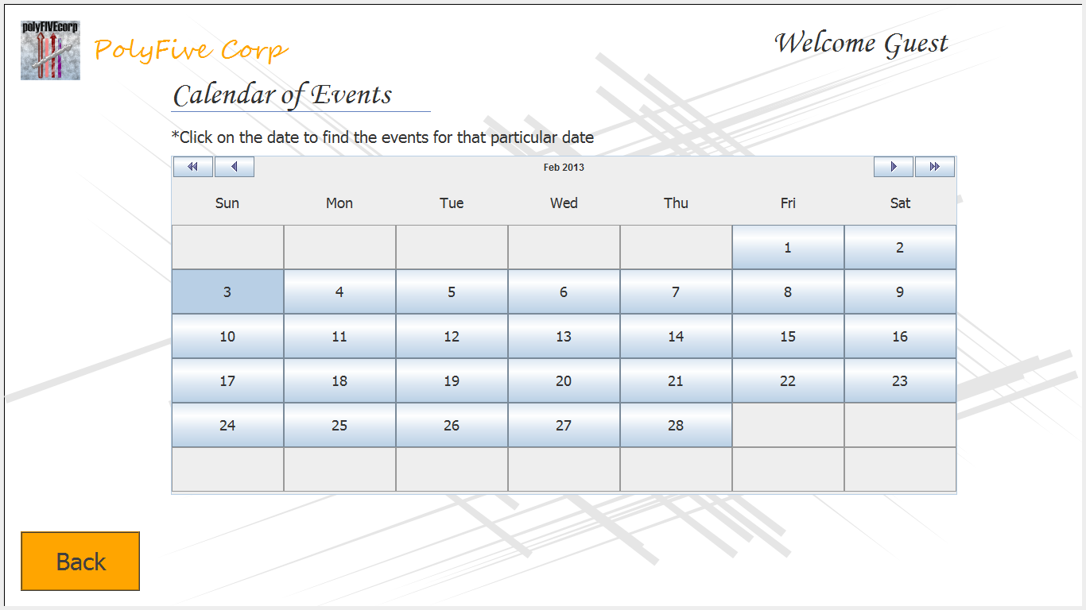

Calendar Screen for Public- The public will get to view events based on the date they choose and will be able to view events for that particular month and not upcoming months.

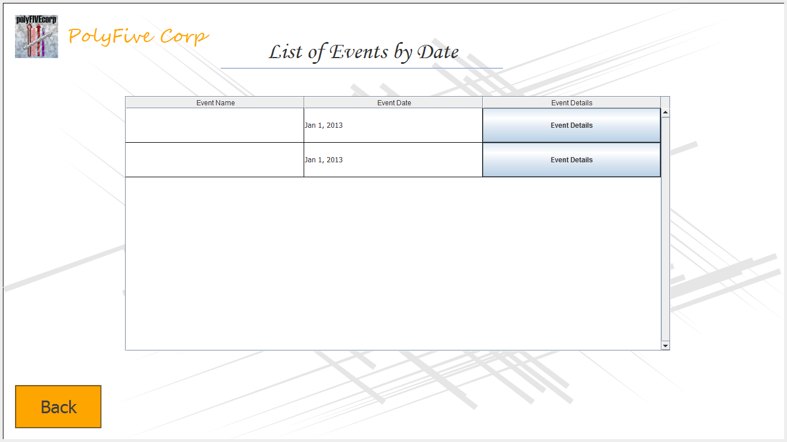

Event Screen- Users will get to view the events that are available on the date they selected and then select what event they want to obtain more information about.

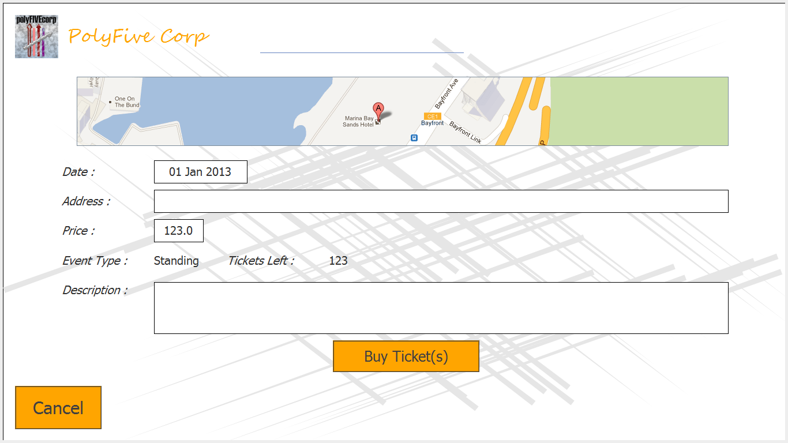

Event Details Screen- Users will get to view the details about the event they selected such as location, event type and description before proceeding on to buying tickets.

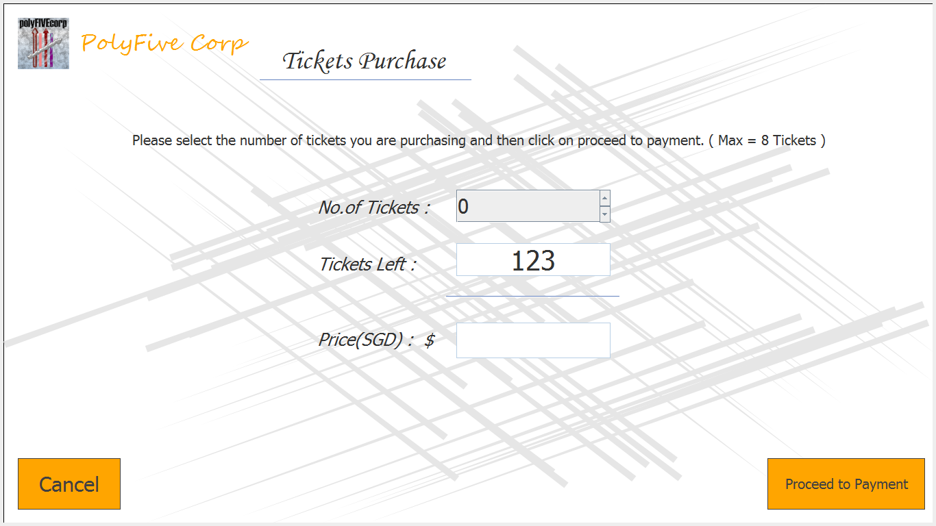

Tickets Purchase Screen for Public- Users will select how many tickets they want with eight tickets being the maximum. Then, they will proceed to payment.

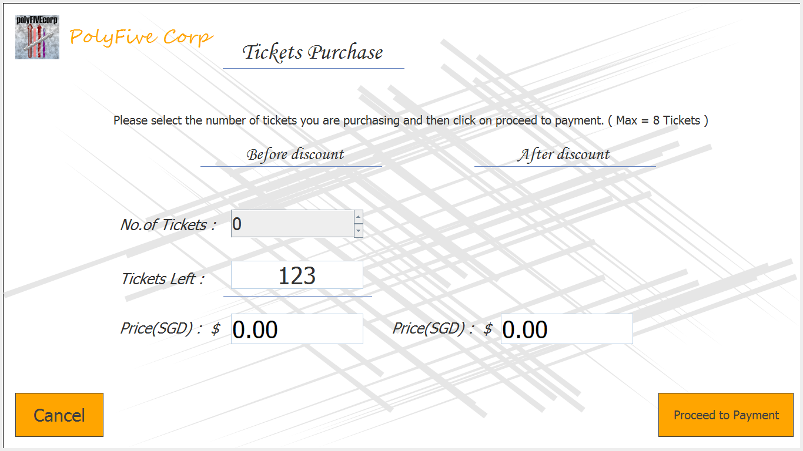

Tickets Purchase Screen for Members- Users will select how many tickets they want with eight tickets being the maximum. Discounts will also be given accordingly to their membership. Then, they will proceed to payment.

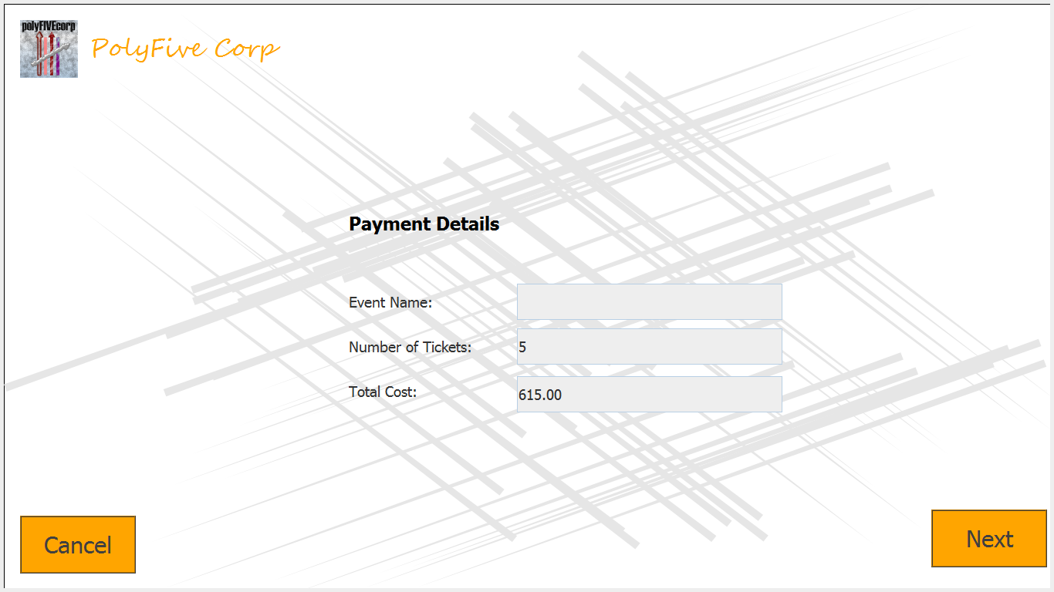

Payment Details Screen- This screen will display the event of the user’s choice together with the number of tickets they intend to buy and the total cost.

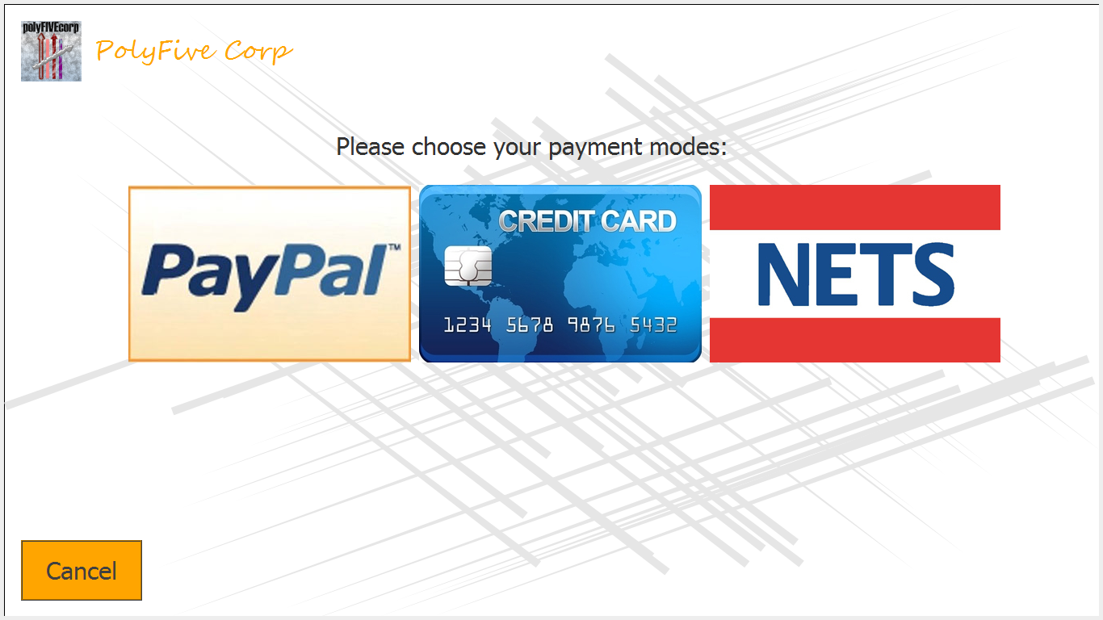

Payment Page- Users are given an option of three payment modes namely, PayPal, Credit Card or NETS.

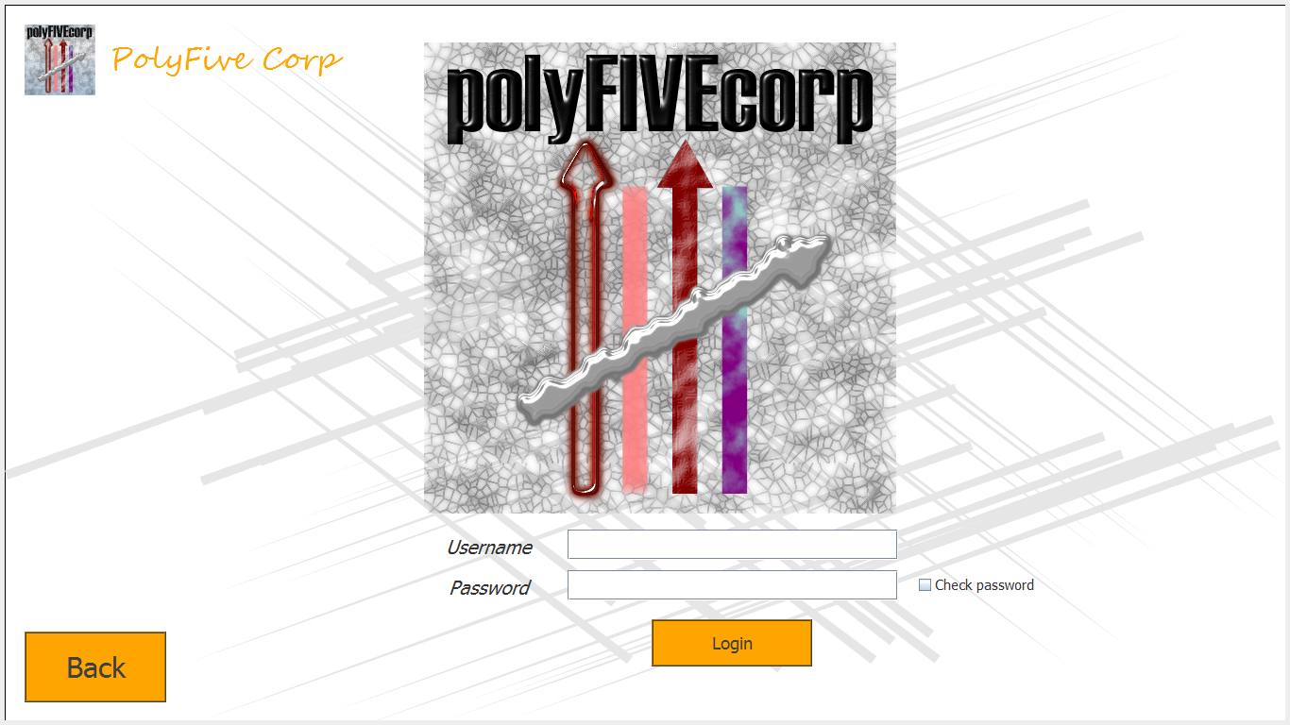

Login Screen- This is screen is where users will login to their accounts. One feature we have here is that they are able to check if they have input the correct password.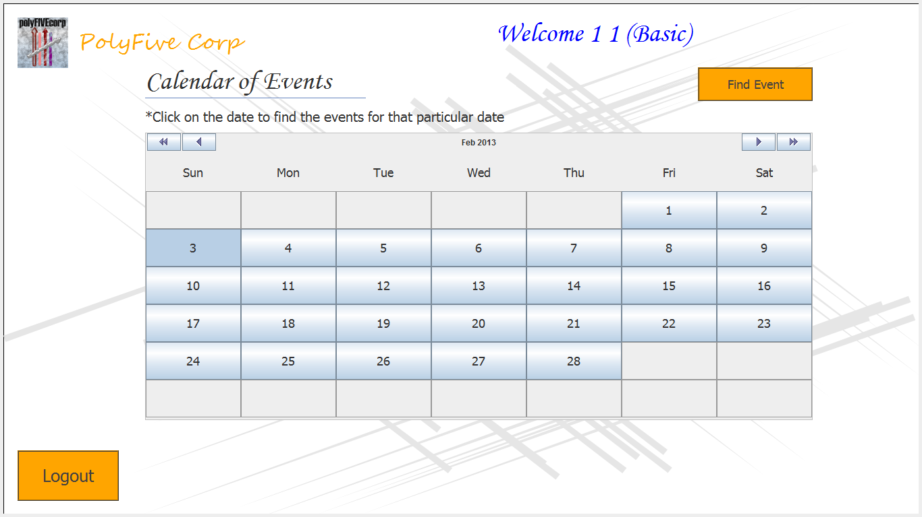

Calendar Screen for all members: Everything is the same as public but the only difference is that they have an option to find events directly and also change their membership information by clicking their logged-in name at the top of the screen.

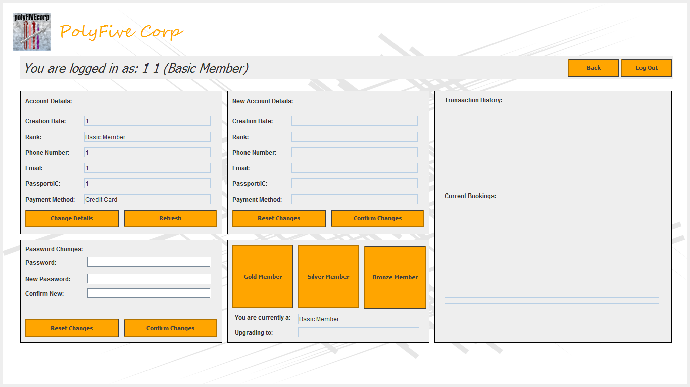

Change of Information Screen- They can reset or change any information if permitted so.

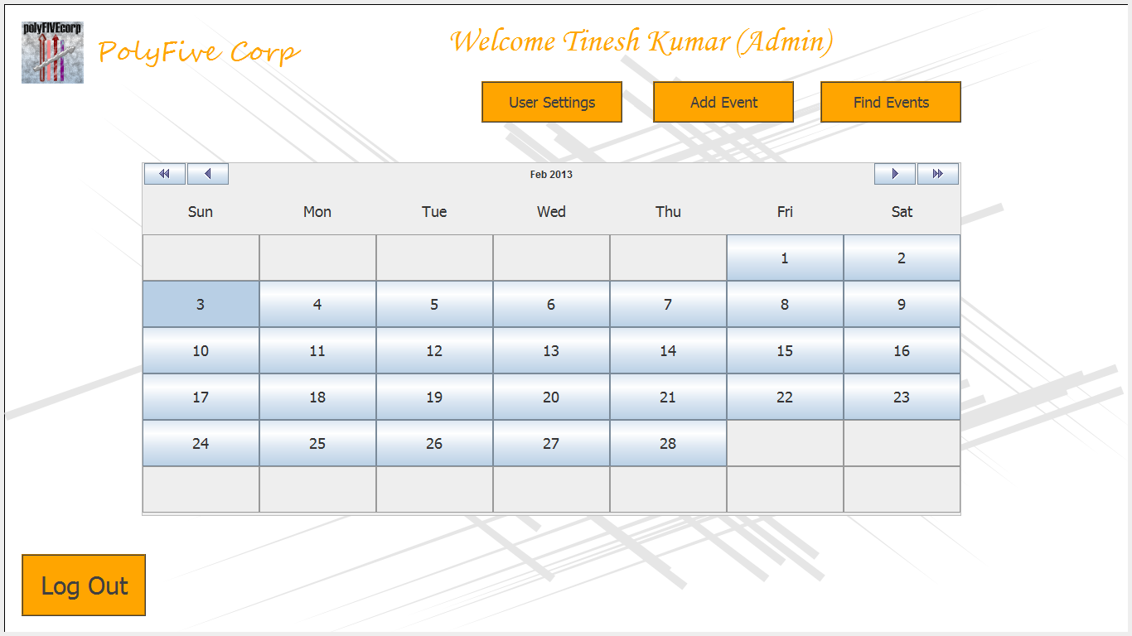

Calendar Screen for Admin- Admins have more options such as finding events, adding events and also ameding or setting user settings.



Event Screen for Admin: Admins will be able to view the events based according to dates for them to view event details or edit them. 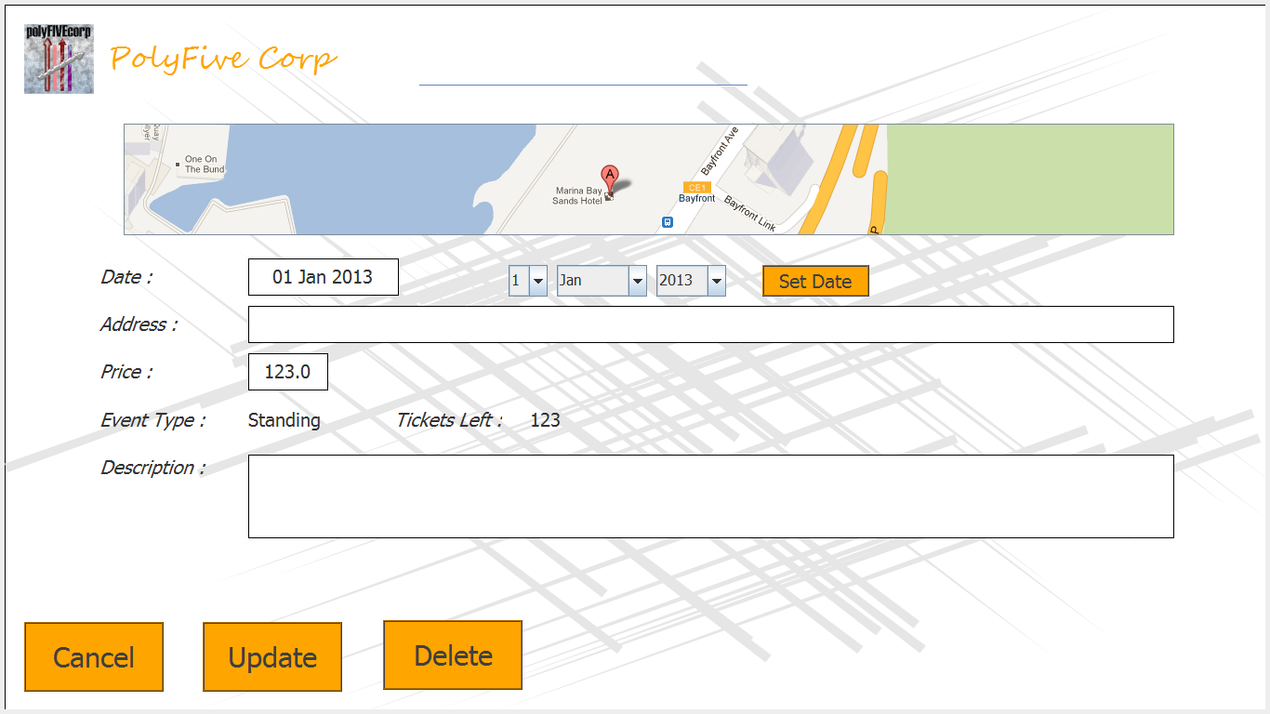

Event Details Screen for Admin-Admins are able to update events by changing the different fields on the screen such as date, price and description. They can also delete events created.

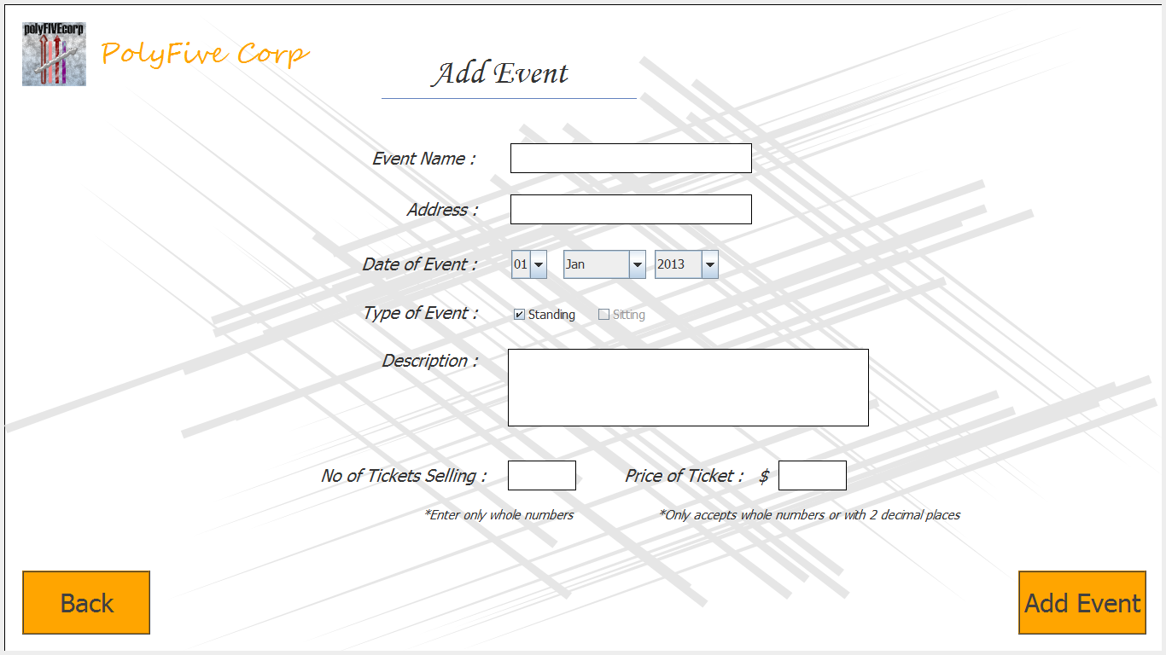

Add Event Screen for Admin- Admins can add events by inputing the event name, address, date of event and description. If standing event type box was checked, admin must set the number of tickets and also the price of the tickets before adding the event. 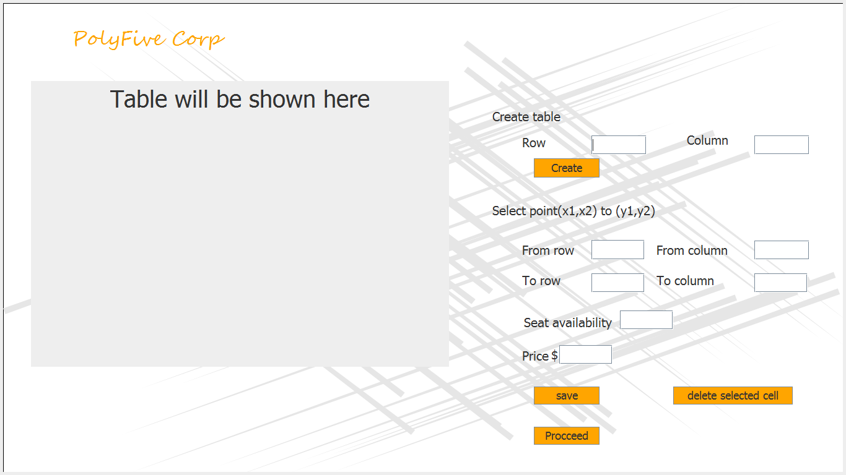

Seating Allocation Screen for Admin: If the sitting event type check box was selected, admin can create seats based on the number of rows and colums and also will be able to set the price of the seats.

# project plan and design

Everybody was assigned to their own user interfaces. We had to individually create our own interfaces and come up with the data we need for our own interfaces. One of us then put all the data into the database and following that we just synchronize our interfaces with the database.



Home Screen- Muhammad Khairyl



Membership Benefits Information Screen- Nicholas Chua, Muhammad Khairyl



Registration Screen- Nicholas Chua, Muhammad Khairyl



Calendar for Public- Muhammad Khairyl



Event Screen-Muhammad Khairyl



Event Details- Muhammad Khairyl



Tickets Purchase Screen for Public- Tinesh Kumar, Muhammad Khairyl



Tickets Purchase Screen for Members- Tinesh Kumar, Muhammad Khairyl



Payment Details Screen- Timothy Yeo



Payment Screen- Timothy Yeo



Login Screen- Muhammad Khairyl



Calendar for Events- Muhammad Khairyl



Change of Information Screen- Nicholas Chua, Muhammad Khairyl



Calendar Screen for Admin- Muhammad Khairyl



Event Screen- Muhammad Khairyl



Event Details Screen for Admin- Muhammad Khairyl



Add Event Screen-Muhammad Khairyl, Tinesh Kumar



Seat Allocation Screen- Ng Qing Hui

# program design

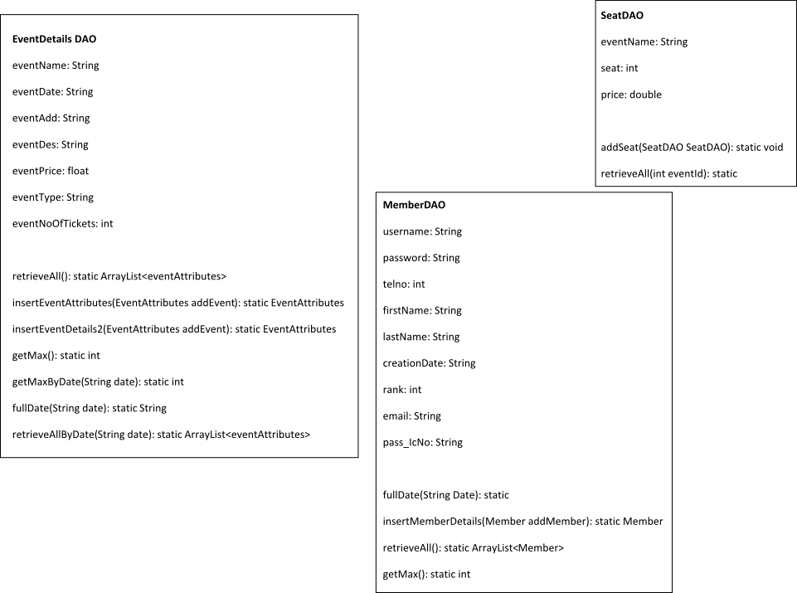

# problems encountered

We had problems when we had to integrate our different interfaces together. We all had different naming conventions and stored our data in different databases. When pulled updated codes from github, some of our codes had conflicts with others. All of us have different skill sets in programming. Some were better than others while some were not. Instead of the weaker ones asking help from the better ones, they just tried to solve their problems on our own which took a really long time. Thus, progress in the project was really slow. We should all have gathered together to solve the conflicts so all of us can progress with our own individual work. However, we did end up with a decent application.

# future enhancements

For future enhancement, we intend on incorporating booking of hotel rooms and taxi services in our application. This will ensure more people will make use of this application as it will be more convenient for them and also ensures that we provide more services for users if our application is successful. We also intend to give notifications of upcoming events via emails and SMS. Cash rebate points are also being considered as an incentive to take up membership with our application and we plan to expand the membership benefits to attract more users. Advertisements will be implemented in our system to ensure sustainability as we will be paid for hosting advertisements in our system.

# conclusion

Our system is an Event Management Application which provides a more easy usage or planning for event organizers. With the easy usage, companies will likely to use our application to help event planners, event mangers, finance and ticketing improve convenience and efficiency in their work. It also provides services for the public and for registered members. With the membership benefits, we hope more people will register as members and make full use of our system. Thus, obtaining a win-win situation for both users and ourselves.

# Appendixes

Public and Members

The public users and members will login if necessary and view events in the calendar screen. From there, they will select which event they are interested in and view the details of the event. Depending on what event type they chose, they will be redirected to the Tickets Purchase Screen or Seats Screen. They will select the number of tickets they want or the seats they want and discounts will be given accordingly. After that, they will be redirected to the Payment Details Screen where they will confirm their purchase. Following that, they can choose their payment mode namely PayPal, Credit Card or NETS.

Admin

Admin will login as admin users and will view the calendar screen as per normal. From there, they can view events, find events, add events or view or set user settings. They can view or find events to either view, update or delete event details. For adding of events, they will be able to set the event details and also the event type either being standing or sitting. If it is standing they will just set the price and number of tickets before proceeding. However, if it is sitting they will be redirected to a screen where they can create seats by rows and columns and also set the price of the seats.